**AUTOMATIC EYE DISEASE PREDICTION USING MACHINE**

**LEARNING ALGORITHMS**

MS.T.SHILPA

Associate Professor  
Department of Information Technology  
Malla Reddy College Of Engineering & TechnologyHyderabad,India.

DEVILA THARUN KUMAR2 BOYAPATI BHARGAV , BHUKYA JHANSI,

Final Year Student Final Year Student Final Year Student

Department of Information Technology Department of Information Technology Department of Information Technology

Malla Reddy College Of Engineering & Malla Reddy College Of Engineering & Malla Reddy College Of Engineering&

Technology Technology Technology

Hyderabad, India. Hyderabad, India. Hyderabad, India.

devilatharunkumar547@gmail.com boyapatibhargav7675@gmail.com

**I.ABSTRACT:**

Inherited retinal diseases cause severe visual deficits in children. They are classified in outer and inner retina diseases, and often cause blindness in childhood. The diagnosis for this type of illness is challenging, given the wide range of clinical and genetic causes (with over 200 causative genes). It is routinely based on a complex pattern of clinical tests, including invasive ones, not always appropriate for infants or young children. A different approach is thus needed, that exploits Chromatic Pupillometry, a technique increasingly used to assess outer and inner retina functions. This paper presents a novel Clinical Decision Support System (CDSS), based on Machine Learning using Chromatic Pupillometry in order to support diagnosis of Inherited retinal diseases in pediatric subjects. An approach that combines hardware and software is proposed: a dedicated medical equipment (pupillometer) is used with a purposely designed custom machine learning decision support system. Two distinct Support Vector 1 one for each eye, classify the features extracted from the pupillometric data. The designed CDSS has been used for diagnosis of Retinitis Pigmentosa in pediatric subjects. The results, obtained by combining the two SVMs in an ensemble model, show satisfactory performance of the system, that achieved 0.846 accuracy, 0.937 sensitivity and 0.786 specificity. This is the first study that applies machine learning to pupillometric data in order to diagnose a genetic disease in pediatric age.

**II.INTRODUCTION**

Inherited Retinal Diseases (IRDs) represent a significant cause of severe visual deficits in children [1]. They frequently are cause of blindness in childhood in Established Market Economies (1/3000 individuals). IRDs can be divided into diseases of the outer retina, namely photoreceptor degenerations (e.g., Leber Congenital Amaurosis, Retinitis Pigmentosa, Stargardt disease, Cone Dystrophy, Acromatopsia, Choroideremia, etc.), and diseases of the inner retina, mainly retinal ganglion cell degeneration (e.g. congenital glaucoma, dominant optic atrophy, Leber hereditary optic neuropathy). Both conditions are characterized by extremely high genetic heterogeneity with over 200 causative genes identified to date, which represent a remarkable obstacle to a rapid and effective diagnosis (<https://sph.uth.edu/retnet/disease.htm>), also considering that the same gene could cause different and heterogeneous clinical phenotypes.

### **A. Current Clinical Evaluation Methods**

The clinical evaluation of IRDs is routinely based on a complex pattern of clinical tests, including invasive ones, that are not always appropriate for infants or young children. For example, electrophysiological testing, that represents the most informative clinical investigation for the diagnosis of inner and outer retinal diseases, often requires sedation of the children. Sedation affects the retinal response and requires a complex healthcare environment (e.g., operating room, pediatric, anesthesiologist, dedicated instrumentation, etc.) with high costs for the health system. Therefore, the clinical diagnosis is not easy and requires specialized centers. Consequently, it takes a long time for the young patients and their relatives to receive a correct and complete screening.

In many cases the electrophysiological responses are below the noise level (for example, extinguished scotopic electroretinogram response is the condition confirming the diagnosis). These responses are therefore not suitable for monitoring changes in visual functionality, that is relevant for evaluating disease progression and therapy efficacy.

### **B. Pupillometry**

A novel approach to support the diagnosis of IRDs would be useful. To this regard, chromatic pupillometry has been proposed as a highly sensitive and objective test to quantify the function of different light-sensitive retinal cells and, therefore, it has been shown helpful to detect the retinal dysfunction caused by IRDs as summarized in the following [2]–​[6].

Photoreceptor cells (rods and cones) exhibit fast temporal kinetics and cause a brisk pupillary constriction in response to light, whereas the inner retinal melanopsin containing intrinsic photosensitive Retinal Ganglion Cells (ipRGCs) exhibits slower temporal kinetics and elicits a sustained pupillary constriction to light stimuli, persisting after light cessation [2]. The relative contributions of the three receptor types (rod, cone, and melanopsin photopigments) to the Pupillary Light Reflex (PLR) have been examined by manipulating the characteristics of large-field (90) flash stimuli and the adaptation conditions (light vs. dark adapted) [3]. For example, high-luminance, long-wavelength (red) flashes presented against a rod-suppressing adapting field elicit a PLR that is predominately cone-mediated whereas low-luminance, short-wavelength (blue) flashes presented to the dark-adapted eye elicits a PLR that is primarily rodmediated. For high-luminance, short-wavelength flashes presented to the dark-adapted eye, there is an initial transient pupil constriction (rod- and cone-mediated) that is followed by a melanopsin-mediated sustained constriction that can last for more than 30s after stimulus offset. The prolonged melanopsin-mediated constriction has been used in clinical protocols to assess inner-retina function [4]–​[6]. Thus, the use of chromatic pupil responses may be a novel way to diagnose and monitor diseases affecting either the outer or inner retina [2]. This evidence suggested that a clinical decision support system (CDSS) based on chromatic pupillometry could be developed in order to support diagnosis of IRDs.

**III.MATERIALS AND METHODS**

### **A. Participants and Experimental Setup**

This study was approved by the local Ethics Committees of the involved clinical centre (University of Campania and University of Milan) and was conducted in accordance with the guidelines of the Declaration of Helsinki [29]. All the involved participants received detailed information on the research protocol and signed an informed consent form prior to the measurement sessions. 20 patients affected by RP and 18 control subjects, characterized by the absence of any ocular diseases and an absolute refraction error lower than 5 dioptres, were enrolled in the present multi-centric research study. The subjects were recruited and evaluated at the Eye Clinic of the Multidisciplinary Department of Medical, Surgical and Dental Sciences (University of Campania Luigi Vanvitelli, Naples), and at the Department of Clinical Sciences and Community Health of the University of Milan. Subjects underwent a standardized evaluation of pupillary response to chromatic stimulation, carried out with a customized DP-2000 binocular pupillometer (NeurOptics, US) showed in Fig.1.

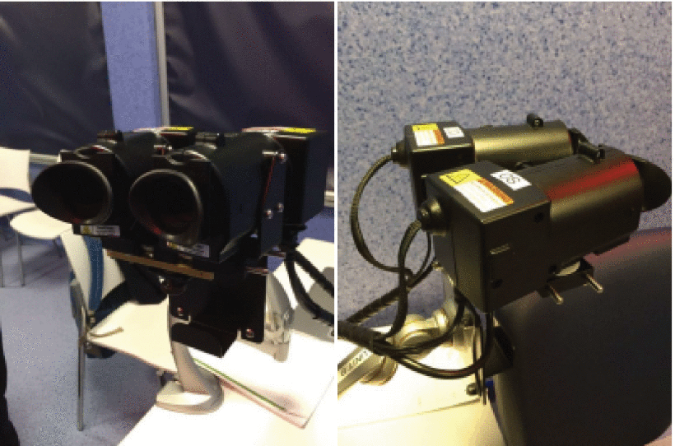

This pupillometry system enables the simultaneous imaging and assessment of both eyes and, furthermore, supports the automatic detection of the pupil contour and the video tracking of its dynamic response to red (λ=622 nm), green (λ=528 nm), blue (λ=462 nm) and white light stimuli. In detail, videos were captured at a 30-Hz frame rate, with an 8-bit grey-level resolution and a spatial resolution of 0.05 mm. In order to build a homogeneous set of pupillometric data, a standard protocol was agreed between the different participating institutions, in accordance with the current literature [2], [6], [30]–​[32]. The identified stimulation sequence required a proper customization of the original firmware, carried out by the manufacturer. Expressly, each measurement session included 10 min of preliminary adaptation to dark, followed by six different stimulation patterns, each applied consecutively to both eyes for three times. Thus, each subject was associated with 18 traces for each pupil, i.e. 36 signals. More specifically, low-intensity impulses against a dark background were used for evaluating rods’ function; high intensity impulses for evaluation of intrinsically photosensitive retinal ganglion cells’ (ipRGCs) function. Moreover, a high-intensity stimulation on a blue background was performed in order to evaluate cones. Each light stimulus lasted 1 s. The phases of the protocol are summarized below, in Fig. 2. Eight out of the 38 test subjects were associated with significantly corrupted signals and were accordingly discarded from the study. Indeed, pupillometric responses may be affected by blinking or eye movements, which could affect the measurement of pupil diameters. The system is actually capable of blinking detection, although this capability was not included in this first study: in the future the protocol could be optimized in order to repeat the stimulation in case of unreliable measurements. The quality of the remaining 30 test subjects was judged by the clinical partners in Naples and Milan. As evident by comparing the signals in Fig. 3 and Fig. 5, this evaluation could be performed by simply plotting the signals and assessing their shapes.

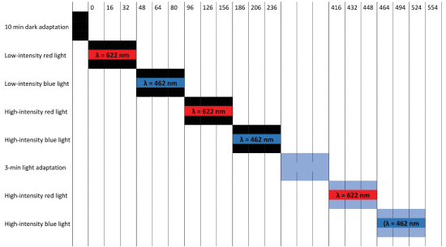

**FIGURE 2.**

Phases of pupillometric protocol, central color is the light one and the side color represent background; numbers in the central part are the intensity of the light stimuli and on top of the scheme there is time express in seconds.

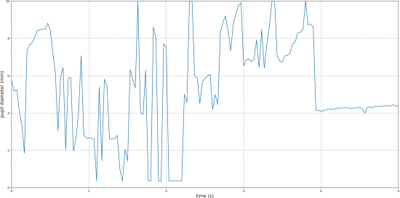

**FIGURE 3.**

Example of irrecoverable signal, the quantity and size of the spikes and artefacts makes it impossible to extract features.

**FIGURE 5.**

Example of filtered signal, short spikes are easily removed.

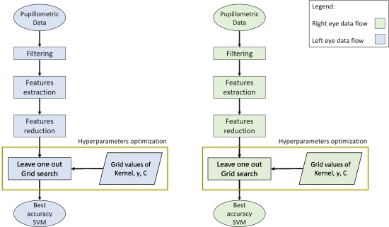

**FIGURE 4.**

Data analysis, selection of features and optimization of the SVM parameters.

### **1. Clinical Decision Support System**

The main stages for the implementation of the RP classifier are shown in Fig. 4, namely: import and pre-processing of the pupillary diameter signals, pupillary feature extraction and reduction, hyperparameters optimization and, finally, training of the supervised classifier. These stages are discussed in the following paragraphs.

#### **1) Signal Pre-Processing**

A first preliminary stage of the CDSS is devoted to the analysis of the raw files, produced by the binocular pupillometer after each measurement session, for the export of the following relevant data:

* Patient ID;
* Bilateral pupillary diameter signals related to each phase of the protocol;
* Diagnosis, i.e. “Pathologic” or “Healthy”, as performed by a clinical specialist.

As detailed in the following, the field diagnosis is used to label the subjects and their related data during the training process of the ML system, whereas the above diameter signals are used to extract clinically motivated features of the pupillary reactivity and for building the input dataset of the supervised classifier. However, before the extraction of the feature set, the raw pupillometric signals must be properly processed in order to attenuate noisy components and, particularly, to cope with potential eye-blink artefacts. Involuntary eye blinking during video capture is indeed associated with abrupt spurious spikes, which might significantly corrupt the resultant traces of the pupil diameter, thus reducing the reliability of the features of interest. In detail, the pre-processing module first involves the application of a Savitzky-Golay (SG) of a third-order smoothing filter [33] and window span of 55 samples. This FIR filter generally improves the original SNR levels without greatly distorting the underlying pupillometric signal. Afterwards, the residual between the original data and the SG-smoothed signal is computed: blink-related artefacts are then identified with values exceeding a properly tailored maximum threshold (0.2 mm) and removed accordingly. Finally, possible gaps produced by the above operation are filled by means of a cubic interpolation, and the resulting trace is once again

filtered by a low-pass filter so as to give final smoothness to the pupillary trace. A sample filtered signal is shown in Fig. 5.

#### **2) Feature Extraction**

We selected the most predictive features based on the following literature [3], [4] [5], [6] [34]. After the pre-processing stage, the following 8-elements vector of features is extracted from each pupillometric signal:

* MAX: maximum pupil diameter at baseline;
* MIN: minimum diameter in correspondence with the peak constriction;
* DELTA: absolute difference between the above values;
* CH: percentage maximum constriction (with respect to the pupillary diameter at rest);
* LATENCY: delay between the light stimulus and the onset of the pupillary constriction;
* MCV: mean constriction velocity;
* MDV: mean dilation velocity;
* CVmax: maximum constriction velocity.

The above eight features, calculated on the filtered signal, were chosen in accordance to the literature about pupillometry in several pathologies [35]–​[37] and in biometric authentication [38]. The same features are regularly used by the clinicians involved in this project and are also provided by the equipment itself in its output files. The time interval used to derive the above features was properly restricted so as to minimize the risk of inaccurate values: namely, MAX and LATENCY are computed in the first second whereas the others are obtained using a 5-s window. The adopted features are represented below, in Fig. 6. The rationale behind the definition of the pupillary LATENCY (see Table 2) is that the contraction starts a few milliseconds after the light stimulus is applied. In detail, this parameter is estimated as follows: the first derivative d′(t) of the pupillometric signal is computed; then, starting from its absolute minimum, the array of values is checked backwards and the time instant corresponding to d′(t)=0 is identified. The detection of an inflection point is avoided since, despite the preliminary SG-smoothing, d′(t) signals are characterized by significant noisy components and zero-crossings are less sensitive to flickering signals. Although this might seem the easiest strategy, it was chosen not to identify the inflection point because it is not possible to have a perfectly smoothed signal which determines a noisy derivative graph. Conversely, the zero-crossing detection is less influenced by flickering signals. In Fig. 7 the latency is highlighted in red while the zero axis in green.

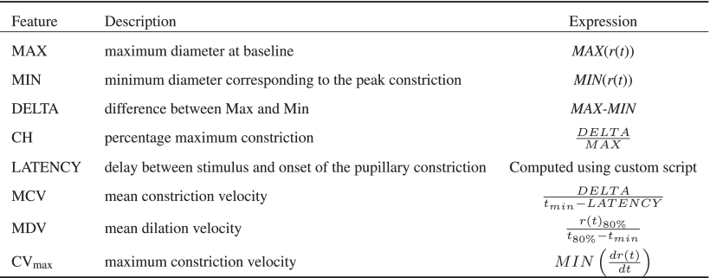

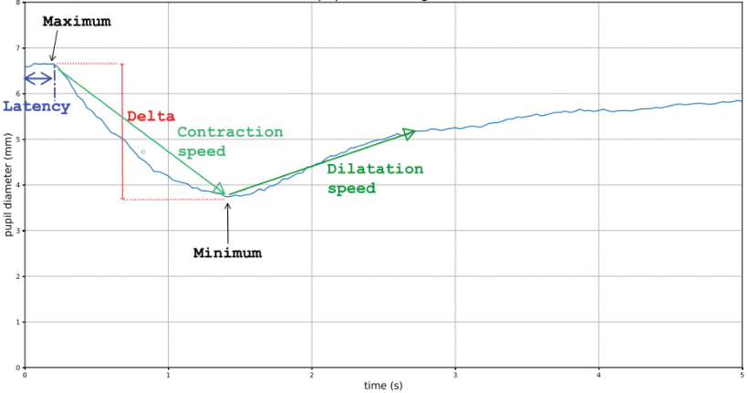

#### **3) Support Vector Machines**

Support vector machines (SVMs) are supervised linear binary classifiers, first introduced by Vapnik [39]. From a conceptual standpoint, SVMs are formally based on the definition of an optimal linear hyperplane of equation [40]:

wtx+b=0(1)

Right-click on figure for MathML and additional features.which separates the feature space into two regions, corresponding to the binary classes of the training data. Specifically, the identification of the above decision boundary is performed via the maximization of the geometric margin between the classes:

MSVM∝1||w||.(2)

Maximizing MSVM is theoretically equivalent to minimizing the term 12||w||2 ; accordingly, the training process of an SVM classifier corresponds to the following optimization problem:

12||w||2.(3).Right-click on figure for MathML and additional features.

yi(wtx+b)≥1i=1,…,N.(4)

where yi∈(−1,+1) are the labels identifying the binary classes. However, in practical classification tasks, real input datasets often cannot be directly separated by a linear boundary. Thus, during training, some instances may be allowed to lie either inside the margin MSVM or on the wrong side of the decision hyperplane, leading to the so-called soft margin SVM:

12||w||2+c∑i=1Nεi.(5)

yi(wtx+b)≥1−εii=1,…,N.(6)

where εi are the so-called slack variables, corresponding to misclassified input instances, whereas the cost C(C∈R0+) is an internal parameter of the classifier. This boundary constant determines the relative weight given to training accuracy and margin MSVM maximization. More specifically, high values of C will penalize the presence of misclassified cases, thus leading to narrow margins between the classes; on the other hand, small coefficients would tolerate the incorporation of misdetections during the training process, and are thus related to wider geometric margins. Numerically, the above optimization is performed via the method of Lagrange multipliers [41], which identifies boundary feature vectors of expression:

w^=∑i=1Nai^yixi(7)

In the above equation, the input observations xi related to non-zero ai^ coefficients are the support vectors, which lie on the decision hyperplane or inside the corresponding margin, thus defining the boundary between the classified clusters. The SVM, however, might achieve improved training accuracy through a nonlinear transformation of the original training dataset. Indeed, this strategy can lead to the generation of more flexible boundaries with respect to an elementary linear hyperplane. Therefore, in addition to the original linear SVM, the present study also explored the performance attainable by transforming the pupillometric features according to a Gaussian radial basis function (RBF): Φ(xi−xj)=e−γ||xi−xj||2 , a popular kernel function which is widely adopted in SVM-based classification, for handling non-linearly separable data clusters. Its scale γ is the second tenable internal parameter of the SVM. Namely, small values of γ favour the identification of smooth classification boundaries which, however, may be comparable to a linear hyperplane for extremely small γ and thus lead to underfitting. Conversely, high values tend to produce more flexible, sinuous margins; still, γ needs proper configuration since very high values may, on the other hand, compromise the generalization capability of the SVM due to overfitting of the training dataset.

#### **4) Feature Reduction**

According to the adopted measurement protocol, previously detailed in the “Participants and experimental setup” section, a total of 288 features was extracted from the 36 pupil reactivity signals, available for each subject to be classified. Due to the relatively high number of features, feature reduction represented a key preliminary operation which was applied to avoid overfitting of the training dataset. In ML applications, a general rule of thumb is to keep the dimension of the input feature space below one fifth of the total number of observations, i.e. the best subjects. In the present study, the set of selected features comes from the results of a recent study [34], which has identified a subset of pupillary features with superior discriminant capability regarding the clinical diagnosis of RP: in detail, the values of the maximum pupil diameter (i.e. MAX) before stimuli 1 and 2 appear to be significantly higher in RP patients which, furthermore, are associated with a reduced pupillary constriction (i.e. higher MIN following stimuli 1, 2, 3 and 4; lower DELTA for all stimuli except 6). Consistently, the following six features were chosen for characterizing each subject: DELTA1, DELTA2, MIN3, MIN4, DELTA5, DELTA6. Although there is an evidence for considering also MAX1, MAX2, MIN1, and MIN2, these four properties are implicitly related to DELTA1 and DELTA2. and were thus discarded in order to keep the final dimension of the feature space as low as possible (see the above consideration). Among the three repeated measurements available for each light stimulus, the features related to just one acquisition were selected, according to criteria reported in Table 3.

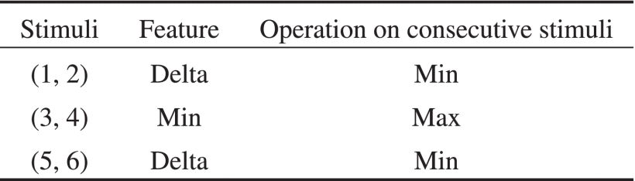

#### **5. SVM Training and Subject Classification**

The overall scheme of the developed CDSS is shown in Fig. 8. In general, the system is designed (so as) to separately label the left and right eyes and, then, to classify the related subject by means of an OR logical operator, i.e. the subject is diagnosed with RP if at least one of the eyes is assigned with the “Pathologic” label (thus improving the global sensitivity of the CDSS). This choice is related to the fact that the artifacts might be not equally distributed between the two eyes. For example, a patient with a frequent blinking in his/her left eye would generate a cleaner signal for his/her contralateral eye. An SVM was selected as supervised (eye) classification algorithm because of its proven solidity and versatility for classification problems [42]. Each SVM classifier was fed with the pupillometric feature vectors acquired from the left and right eyes of 30 of the enrolled subjects (see Participants and experimental setup). As previously mentioned, linear and RBF kernels were alternatively used for both the left-and right-eye classifiers, so as to explore and compare their performances. The optimization of the hyper-parameters of the SVM, i.e. the boundary constant C and the scale λ of the non-linear RBF kernel, represents a fundamental step for the achievement of improved classification performances (see the above paragraph “Support Vector Machines”).

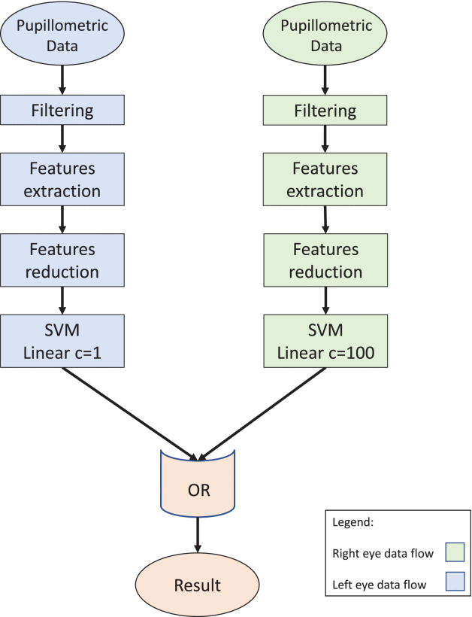

**IV.Result AND ANALYSIS**

The optimal combination of the SVM hyperparameters, returned by the data-driven tuning process, are reported in Tables 5 and 6, alongside the related classification accuracy achieved on the 30 available subjects. Tables 7 and 8 summarize sensitivity, specificity and accuracy for the final ensemble model (schematized in Fig. 8). In details, these performance scores were derived by comparing the actual class of the subject - as assigned by the physician - with the class obtained

by applying an OR logical operation to the two labels separately returned by the tuned SVMs for each eye. As expected, this strategy determines an increase in the overall sensitivity of the CDSS. It is worth to specifying that only one table is reported because both the linear and RBF kernel functions gave the same results in the ensemble logic.

**Validation process.**

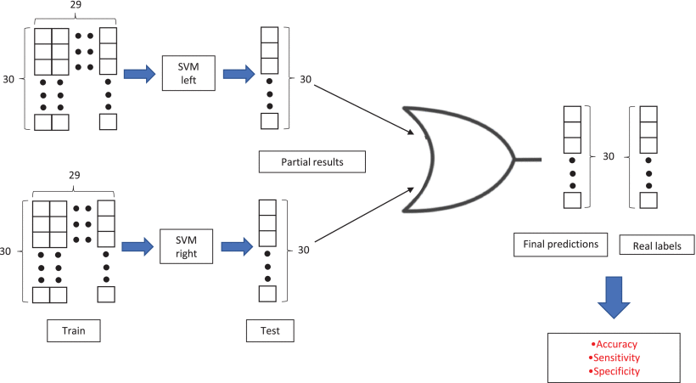

**V.RESULT SCREENSHOTS:**

To run project double click on ‘run.bat’ file to get below screen



In above screen click on ‘Upload Pupillometric Dataset’ button to load dataset



In above screen uploading ‘dataset’ folder and after upload will get below screen



Now click on ‘Run Filtering’ button to perform filtering on dataset to ignore raw data



In above screen after filtering we got 593 patients data and now click on ‘Run Features Extraction’ button to read features from raw file



In above screen extracted features such as MIN, MAX pupil diameter etc. now click on ‘Run Features Reduction’ button to remove unimportant features and then generate train and test model for classification and to get pupil diameter graph below

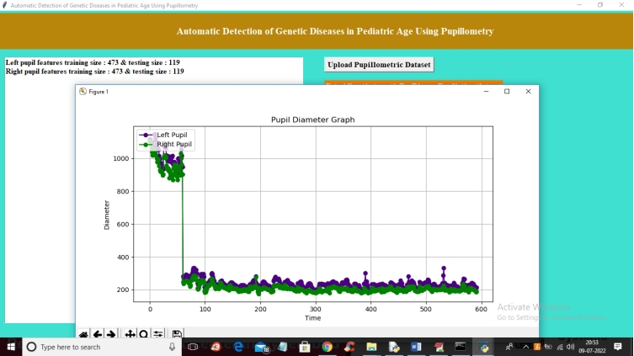

In above graph x-axis represents time of pupil capture and y-axis represents diameter of pupils. Blue line represents left pupil and green line represents right pupil. Close above graph to get below screen



In above screen application using 473 records for training and 119 records for testing from total 593 records. Now click on ‘Run SVM on Right Eye Features’ to run SVM classifier



In above screen with right pupil SVM got 58% accuracy and now click on ‘Run SVM on Left Eye Features’ button to run SVM classifier on left eye data

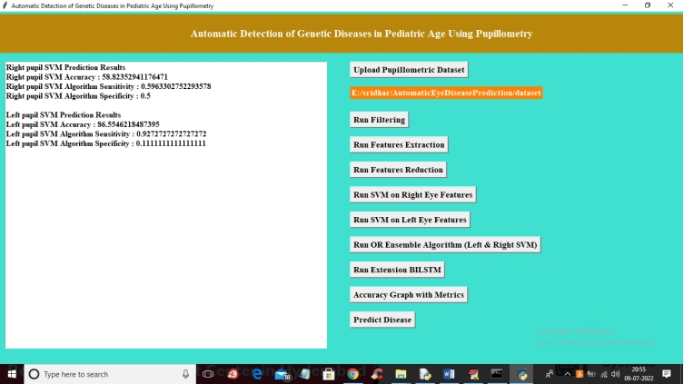

In above screen with left pupil data we got 86% accuracy and now click on ‘Run OR Ensemble Algorithm (Left & Right SVM)’ button to combine both classifier to choose classifier with better accuracy

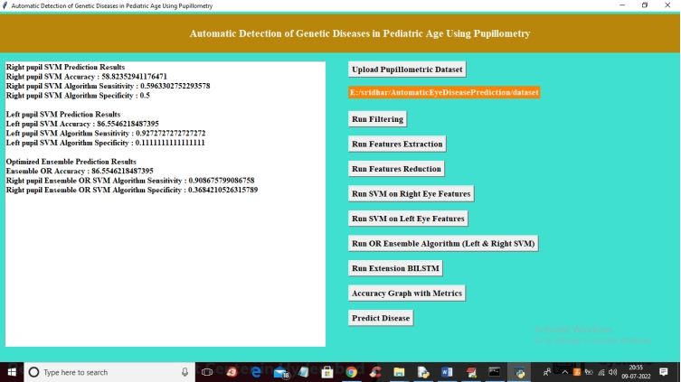

In above screen with Ensemble OR SVM we got 86% accuracy and now click on ‘Run Extension BILSTM’ button to run BILSTM algorithm and get below output

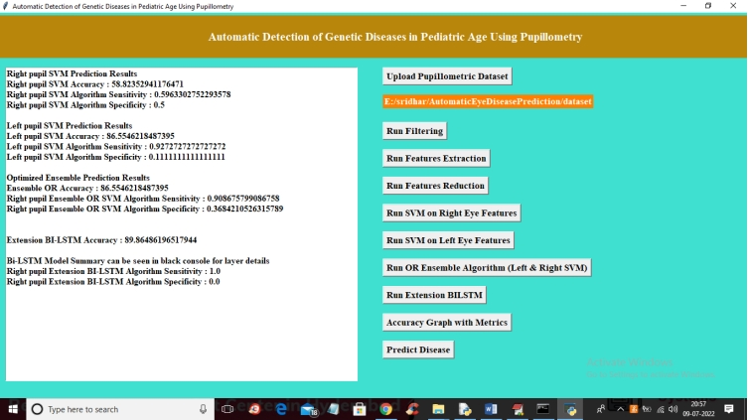

In above screen with extension ‘BILSTM’ we got 89% accuracy and now click on ‘Accuracy Graph with Metrics’ to get below accuracy graph

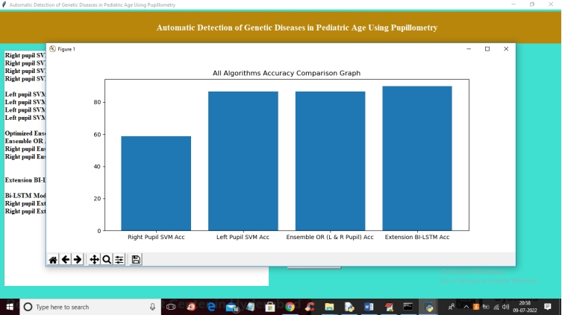

In above graph x-axis represents algorithm name and y-axis represents accuracy and in all algorithms extension BILSTM got high accuracy and now click on ‘Predict Disease’ button to upload test data and predict disease. In below test data we can see only pupil values are there but not disease information and classifier will predict disease information after applying classifier on it.

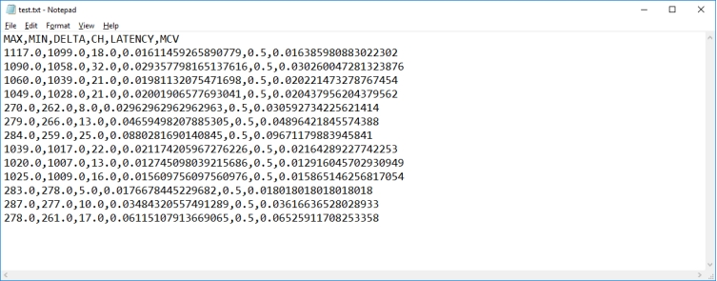

In above test data ‘test.txt’ we have only features values and after uploading classifier will predict disease



In above screen uploading test data and after upload will get below screen

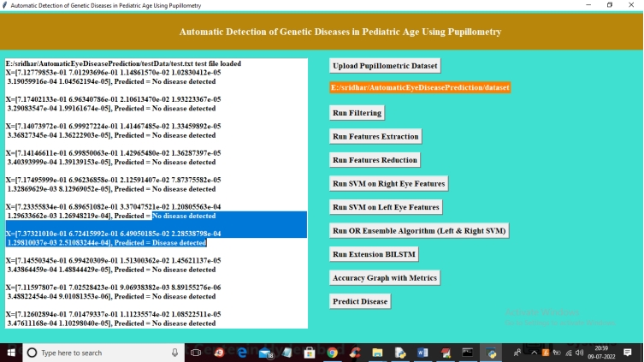

In above screen for each test record classifier displaying predicted result as ‘disease detected’ or ‘no disease detected’. In above screen in square bracket we can see TEST values and after square bracket we can see predicted result as pupillometri disease detected or not.

Here we are extracting data from binocular device data and we are splitting train and test data as random so accuracy may vary for each run based on collected data from binocular device data.

**V.REFERENCE**

1.

X.-F. Huang, F. Huang, K.-C. Wu, J. Wu, J. Chen, C.-P. Pang, et al., "Genotype–phenotype correlation and mutation spectrum in a large cohort of patients with inherited retinal dystrophy revealed by next-generation sequencing", Genet. Med., vol. 17, pp. 271-278, Apr. 2015.

2.

R. Kardon, S. C. Anderson, T. G. Damarjian, E. M. Grace, E. Stone and A. Kawasaki, "Chromatic pupil responses. Preferential activation of the melanopsin-mediated versus outer photoreceptor-mediated pupil light reflex", Ophthalmology, vol. 116, no. 8, pp. 1564-1573, 2009.

3.

J. C. Park, A. L. Moura, A. S. Raza, D. W. Rhee, R. H. Kardon and D. C. Hood, "Toward a clinical protocol for

assessing rod cone and melanopsin contributions to the human pupil response", Invest. Ophthalmol. Vis. Sci., vol. 52, no. 9, pp. 6624-6635, Aug. 2011.

4.

A. Kawasaki, S. V. Crippa, R. Kardon, L. Leon and C. Hamel, "Characterization of pupil responses to blue and red light stimuli in autosomal dominant retinitis pigmentosa due to

5.

A. Kawasaki, F. L. Munier, L. Leon and R. H. Kardon, "Pupillometric quantification of residual rod and cone activity in Leber congenital amaurosis", Arch. Ophthalmol., vol. 130, no. 6, pp. 798-800, Jun. 2012.

**VI.CONCLUSION**

This paper describes a new approach for supporting clinical decision for diagnosis of retinitis pigmentosa starting from analysis of pupil response to chromatic light stimuli in pediatric patients. The system was developed to clean artefacts, extract features and help the diagnosis of RP using a ML approach based on an ensemble model of two fine-tuned SVMs. Performances were evaluated with a leave-one-out cross-validation, also used to identify the best combination of internal parameters of the SVM, separately for both the left and right eyes. The class assigned to each eye were combined in the end with an OR-like approach so as to maximize the overall sensitivity of the CDSS; the ensemble system achieved 84.6% accuracy, 93.7% sensitivity and 78.6% specificity. The small amount of data available for this work, calls for further tests with a larger data pool for validating the performance of the system. Future scope includes testing the same approach with different devices. A problem that came out with great evidence, at the signal acquisition stage, is the frequent presence of movement artifacts. This is due to the particular shape of the device, together with the young age of the enrolled patients. Devices with different frame, including also systems based on smartphones, are going to be investigated. Moreover, considering the duration of the whole acquisition protocol, the procedure would benefit of some systems to capture the attention of the young patient (and his/her